VxRail Ansible Collection

Abstract
This document provides details on the configuration and modules within the VxRail Ansible Collection.
August 2020

Revisions
Date | Description
August 2020 | Draft – Jeff Purcell

About this guide
This document provides details on the installation and consumption of the VxRail Ansible Collection of Python modules. These modules are provides as working samples of tasks that can be performed on a VxRail Cluster environment leveraging the VxRail REST API.

The information in this publication is provided “as is.” Dell Inc. makes no representations or warranties of any kind with respect to the information in this publication, and specifically disclaims implied warranties of merchantability or fitness for a particular purpose.

Use, copying, and distribution of any software described in this publication requires an applicable software license.

Copyright © 2019 Dell Inc. or its subsidiaries. All Rights Reserved. Dell, EMC, Dell EMC and other trademarks are trademarks of Dell Inc. or its subsidiaries. Other trademarks may be trademarks of their respective owners. [3/3/2021] [Document Type] [[Manager]]

Table of contents
Revisions 2
About this guide 2
Table of contents 4
Introduction 5
VxRail Collection Overview 6
Collection Structure 6
Modules 6
Roles 8
Playbooks 9
VxRail Collection Installation 11
1. Prepare the environment by 11
2. Configure the Ansible environment 11
VxRail Ansible Modules 13
add-vxnode 15
vx-freenode 19
Remove Host (vx-rmnode) 19
vx-vcmode 21
vx-diskinfo 23
VxRail LCM (vx-lcm) 26
Cluster Health System Status (vx-health) 30
Cluster Hosts Error! Bookmark not defined.
Cluster Shutdown 31
Log Collection (vx-getlogs) 33
Support Logs Error! Bookmark not defined.

Introduction

The VxRail Cluster provides a number of APIs which are exposed through a REST interface. These APIs include methods that can be accessed with a REST client to perform basic get requests to query the environment for system state and component properties, as well as POST and PATCH methods which we allow for updates or modification to the environment.
The VxRail API can be accessed via a standard REST client by connecting to the VxRail manager at the fully qualified domain name (FQDN), or IP address followed by the REST path to the API, for example https://mgt-vxm.lab2.local/rest/vxm/v1/requests which provides a get method to review all of the task requests that have been initiated on this cluster.
There is an API document which is provided at the following URL whjch breaks down each API and provides samples of how those APIs can be exercised. If you are simply curios about the API set and how to get your hands dirty with the APIs, that is a good place to start.
This document intends to build upon the APIs capabilities and establish workflows which combine APIs, check for system state, produce log files, and work towards repeatable outcomes, while abstracting some of the minute details that are required for each http request method.

VxRail Collection Overview

Collection Structure
An Ansible collection provides a consistent structure for creating and distributing the scripts and code to automate an infrastructure. In the VxRail environment. Illustrated in figure 1, the primary components are plugins or modules where you will find the python modules that are used to interact with the VxRail Clusters, roles which define variables and tasks, and playbooks which control the flow and execution of individual plays.
Additional items in the directory are the galaxy.yml which contains the meta data for the collection, README.me and docs which contains optional documentation for the collection. As we will see in the plugins section, each python module contains self documented text which can be used to get details about the module along with sample usage.

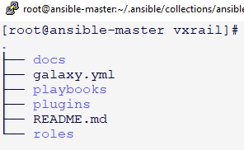

Modules
The VxRail Ansible collection is, as the name suggests, a collection of ansible modules which can be used to provide infrastructure as code within a VxRail environment.
There are presently sixteen modules which support a number of built in playbooks for task automation and data collection and management of a VxRail Cluster. Modules are written in python3
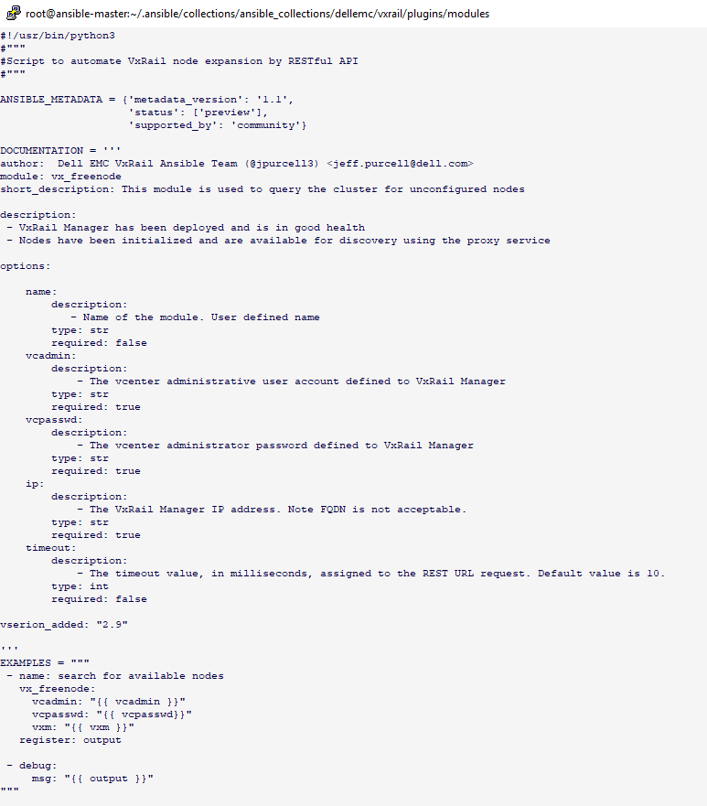

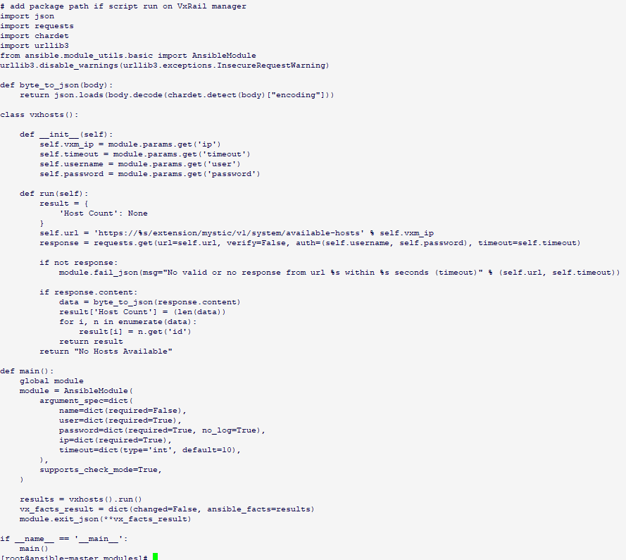

Roles
An ansible role is a container for defining a particular task or function. It is defined within a directory structure that contains additional sub directories for objects such as variables, tasks, or files.
The tasks defined for each role are defined within the <role>/tasks/main.yml file.
The benefit of roles is that they behave similar to functions in programming language. That is, you define all of the properties of the function (or task) within the role, and you call the role from the playbook. This approach allows for cleaner playbook definition and flow while isolating the development, testing and enhancements of the role. Figure 3 illustrates the roles that exist in this version of the VxRail Collection.
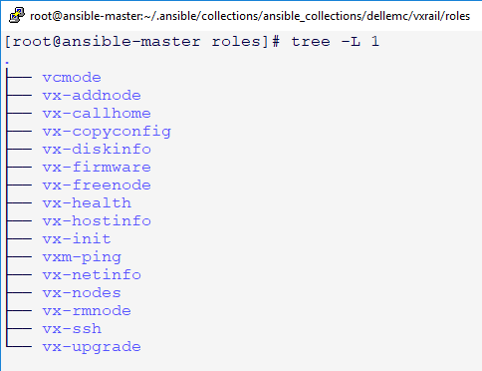

Playbooks
Playbooks are the execution object for the collection. When attempting to perform a task against the VxRail Cluster, we first define it within a playbook and then use the ansible-playbook command to access the plays within that playbook. A playbook may contain one or more plays. A playbook for system health, for example, may be a simple playbook with a play to call the vx-health role and return the state of the vxrail cluster defined within to the play, while vx-lcm includes a number of plays to upload the image file, prepare the cluster, confirm the system state, initiate the lcm process, and monitor the execution.
The playbooks are intended to be flexible and provide a method to construct the type of workflows you need to perform your intended operation.
Some modules are basic calls to the VxRail system that can be performed through a custom module, or directly within an ansible playbook. 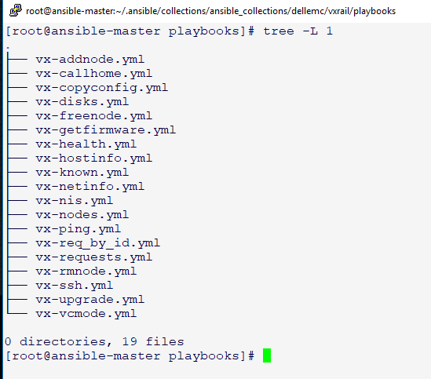

VxRail Collection Installation

The VxRail Collection requires a Linux environment with the following components installed. The environment used to develop the modules was CentOS version 7.
- Python3
- Ansible 2.9 or later
- Chardet
- Requests
- Urllib3
- Pip3

Prepare the environment by
- Deploy the Linux operating environment for Ansible.
  - Allocate at least 100 GB of local storage.
- Configure system properties, hosts files, networking, dns, etc.
- Perform a system update to upgrade the environment
  - Centos 7
    - sudo yum update
    - sudo yum install epel-release
    - sudo yum --install ansible
    - PIP
      - pip install requests
      - pip install chardet

  - Centos 8
    - dnf upgrade
    - dnf install python3-pip
    - pip install ansible

Configure the Ansible environment
- Edit the /etc/ansible/hosts file
  - Add a group called vxrail including brackets [vxrail]
  - Add host entries for all VxRail Manager hosts using the following example
vxr1 ansible_host=172.16.0.10 ansible_connection=ssh ansible_user=mystic ansible_ssh_pass=Emc-1234!
- Edit the local /etc/hosts file and /etc/resov.conf to ensure the vxrail manager hosts systems IPs and hosts names can be resolved via DNS and/or the hosts file.
- Test connectivity to each host
  - Issue the ansible -m ping command with the vxrail group name to ping all hosts.
  - Issue the anible -m ping <host> for isolated host testing.
- Edit the /etc/ansible.cfg file to set site specific properties for the environment
- Create a /etc/ansible/group_vars directory
- Create a file called /etc/ansible/group_vars/all.yml file.
  - Create entries similar to the following within the all.yml file
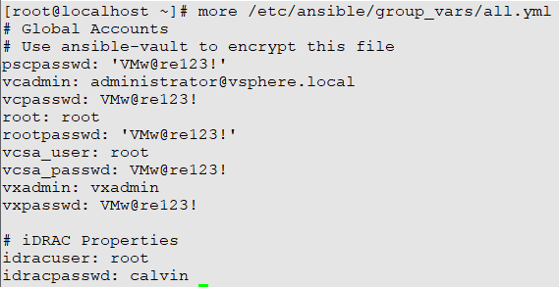
- Create a host_vars file for each vxrail manager cluster you wish to manage.
  - The host_vars file provides cluster specific properties that are accessed by the playbooks
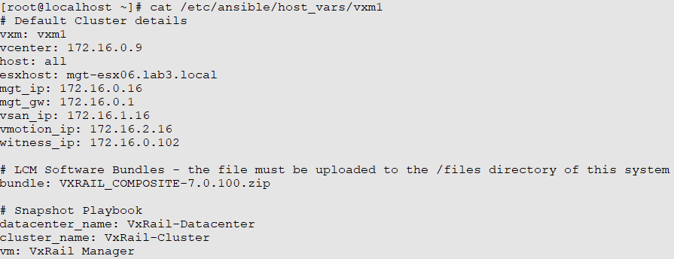

Obtain the collection from github.
- Login into the ansible-control VM
- Change directory to /etc
- Run git clone to copy the collection to the local file system
  - git clone https://github.com/jpurcell3/ansible.git

Use the ansible galaxy command to install the collection
- Ansible-galaxy collection install dellemc-vxrail-1.0.0.tar.gz
- The default install location when logged in as the root account is:
/root/.ansible/collections/ansible_collections/dellemc/vxrail/'

It may be helpful to add the following .bash_profile aliases to limit typing
- alias cdp='cd /root/.ansible/collections/ansible_collections/dellemc/vxrail/playbooks'
- alias cdm='cd /root/.ansible/collections/ansible_collections/dellemc/vxrail/plugins/modules'
- alias cdr='cd /root/.ansible/collections/ansible_collections/dellemc/vxrail/roles

To ensure reliability of the collection, configure the SSH keys and validate connectivity before proceeding to the modules and playbook tasks.

Host and Group Variable
Ansible provides a method to define playbooks using variable substitution. The variables defined within the playbooks can be set in a number of way including files, command line, or another play within the playbook. This feature enhances the usability of playbook across a number of endpoints and workflows. In this collection we make extensive use of variables so that we can use the same playbook across any VxRail Cluster, or all of them in some cases.
Variable are passed via command line using the -e ‘param=value’ option or stored in a file using the following format:
Param1: value
Param2: value
Etc.
We can access the variables within playbooks using jinja2 style formatting so that for example
Host: “{{ vxm7 }}”
Maps to a host name vxm7

The files allow for simplified configuration and passing of parameters within playbooks. The format of each file is in
key: value
The parameter values can be referenced from within the playbook by either creating one of the default vaiables files and referencing it within the playbook, or explicitly importing the parameter file.
Once we have established the proper file reference, we can reference a variable using jinja2 formatting i.e. “{{ key }}” will resolve the value assigned to it in the respective vaiables file.
Note; it is important to understand the order of precedence to ensure your variable contains the value you expect.
There are two examples of variable inheritance that are used with the VxRail Modules and playbooks.
host_vars which contains cluster specific variables and group_vars which contain global parameters that are relevant to all clusters in the environment.
Host_vars
The default location for these files is in /etc/ansible/host_vars and /etc/ansible/group_vars
A multi-cluster environment will likely contain many individual host_vars vraible files the sample environment may contain
In the screen shot below each vxm* file represents a different VxRail Cluster which may have slightly different configuration properties based upon the existing configuration, entitlements, etc.
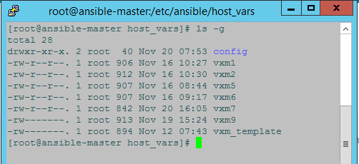

The /etc/ansible/group_vars/all.yml file is used to define global parameters that are available to all playbooks. So the parameters in the all.yml file become the default values for those properties. There is an order of precedence for properties, and the values contained within the all.yml file can be overwritten by a host_vars property or at the command line.

VxRail Ansible Modules

Configuration

Module: vx-ssh

Description: Add VxRail Manager public keys to Ansible Control Node
This playbook performs an ssh-keyscan of hosts defined within the /etc/ansible/hosts file. It returns and updates the $HOME/.ssh/known_hosts file with the public keys of each host in order to provide a reliable communication interface between ansible and the VxRail Manager host.
Dependencies:
- /etc/ansible/hosts is populated will vxrail manager hosts and IP addresses.
- VxRail Manager hosts have been configured and are network accessible
- DNS has been configured with forward and reverse lookup entries for the VxRail Manager servers.
- Ansible Control VM DNS is configured to resolve hosts with lookup and dig commands.
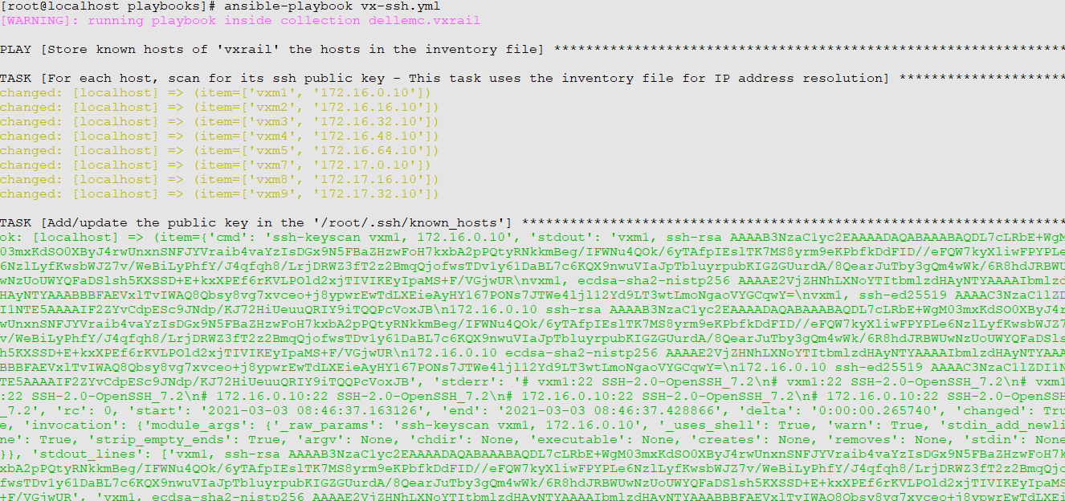
Execution:
ansible-playbook vx-ssh.yml
Validation: Upon successful execution, issue the following command to validate communication to each host.
ansible -m ping <vxrail manager group> i.e. vxrail

Enable SSH for root account (vx-sshd)
In certain cases, it may be desirable to establish a console session to the VxRail Manager console. The common client protocol used for accessing the console is SSH, however the default configuration disallows the root account.
The following module allows for the modification to the SSH policy in order to support a remote SSH connection using the root account. This action can be reversed after the task requiring root access has been completed.
Note: This task requires the root password, so there is inherent protection in that requirement and there is no intent to augment existing security configuration.
The vx-sshd role includes a modified version of the /etc/ssh/sshd config file. That file is copied to the target system using the elevated (become) privileged role within the playbook. Once the file has been copied, the sshd service on the target system is restarted and the SSH service will allow for root access to the system.
Usage: ansible-playbook vx-sshd.yml -e ‘vxm=vxr1’ -K
Note: -K denotes the become user role defined in the playbook. In this case the become user is root.
Upon successful completion you should be able to ssh to the target VxRail VM using the root account and password.

Module: (vx-ping)

Description: The vx-ping module or playbook is a very basic utility to check network accessibility between the Ansible Control VM and the VxRail Manager nodes. The intent is to confirm that the SSH key exchange and trust, known_hosts entries, and firewall ports are configured to support ansible communication to the VxRail Manager Host.
- hosts: localhost
gather_facts: False
tasks:
- name: check if {{vxm}} port 443 is accessible
wait_for:
host: "{{vxm}}"
port: 443
state: started
delay: 0
timeout: 1
register: status

- debug:
msg: "{{status}}"
when: status.failed == false

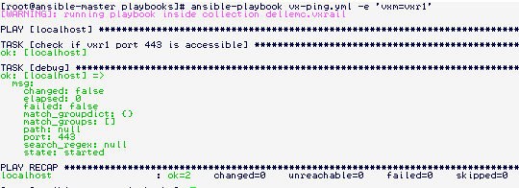

Host Modules

add-vxnode
Description: The add-vxnode module performs cluster expansion by adding an unconfigured node to an existing cluster.
Dependencies:
In order for the node expansion to work properly the node must be
- In a factory initialized state from manufacturing or reset using one of the re-imaging tools such as RASR, NIM, etc.
- Forward and reverse DNS entries have been added for the node IP addresses
- IP addresses have been allocated for the management, VSAN, VMotion Networks.
- Physical cabling and switch VLAN configuration have been performed for the uplink interfaces.

The add-node module takes several parameters for successful execution.
These parameters are
vcadmin: vcenter administrative account
vcpasswd: vcenter administrator password
ip: vxrail manager resolvable FQDN or IP address
esxhost: ESX Hostname
vxuser: VxRail Administrative user account
vxpasswd: VxRail Admin account password
esx_mgt: VxRail Node Management IP address
esx_vsan VxRail Node vSAN IP address
esx_vmotion VxRail Node vMotion IP address
root_passwd: VxRail Node root password

Commonly used parameters can be stored in the /etc/ansible/group_vars/all.yml file to minimize the number of command line arguments passed to the module. The all.yml file should be encrypted, and password protected using the ansible-vault command.

As mentioned, it is possible to modify the values within the /etc/ansible/group_vars/all.yml file. That approach allows you to simply run the playbook as follows and the parameters will be passwd from the values stored within the file.

# ansible-playbook vx-addnode.yml

An alternative approach is to override those values using the -e argument and provide or override the values at the command line.

# ansible-playbook vx-addnode.yml -e ‘vxm=vxr3 esxhost=mgt-esx05.lab5.local esx_mgt=172.17.32.15 esx_vsan=172.17.33.15 esx_vmotion=172.17.34.15”

In this example we have changed the hostname, and IP addresses for management, vSAN, and vMotion, The remaining properties were read from the default parameters file (all.yml).

The add-vxnode module peforms the following functions:
- Checks node availability
- Determines compatibility of node with existing nodes within the cluster.
- Checks for available IP addresses within the network pool and if necessary expands the pool with IP addresses provided
- Performed cluster expansion
- Monitors task execution and outputs results to /tmp/vx-addnode.log

Available Nodes (vx_freenode)
Description: The vx-freenode module is used to query the cluster and determine if there are compatible nodes available for expansion.
The module returns an unordered list of nodes that can be used for subsequent tasks, most specifically the vx-adnode module.
Dependencies:
In order for the node expansion to work properly the node must be
- In a factory initialized state from manufacturing or reset using one of the re-imaging tools such as RASR, NIM, etc.
- Forward and reverse DNS entries have been added for the node IP addresses
- IP addresses have been allocated for the management, VSAN, VMotion Networks.
- Physical cabling and switch VLAN configuration have been performed for the uplink interfaces.

Parameters:
vcadmin: vcenter administrative account
vcpasswd: vcenter administrator password
ip: vxrail manager resolvable FQDN or IP address

Execution will require these parameters defined above, unless that have been added to a variables, or global variables (all.yml) file, in which case they can be parameterized using jinja2 formatting within the playbook or task.

# ansible-playbook vx-addnode.yml

The module returns node objects as seen below.
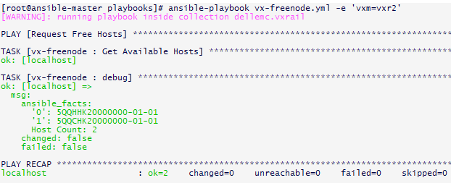

Remove Host (vx-rmnode)
The vx-rmnode will remove an existing node from the VxRail Cluster. Since the node is also a part of an active vCenter cluster the node is first put into maintenance mode, removed from the vcenter cluster, removed from the VxRail Cluster, and powered off.
After completion the IP addresses are released to the IP Pools. The VxRail node will need to be re-imaged in order to reuse it with another cluster.
Dependencies:
- VxRail Manager must be accessible on the network
- The Ansible control node must be configured to support ssh commands to the VxRail Manager.
- VxRail Manager in healthy state
- VxRail Node healthy and powered on.

Required parameters:
- vcadmin: vcenter administrative account
- vcpasswd: vcenter administrator password
- ip: VxRail manager resolvable FQDN or IP address
- esxhost: esx fqdn to be removed
- vcroot: vCenter root account
- vcrootpasswd vCenter root password
Execution:
ansible-playbook vx-rmnode.py
Log File: /tmp/vx-rmnode.log

Configured Cluster Nodes (vx_nodes)
Description: The vx_nodes.py modeuls and sample vx-nodes playbook are used to provide details about the configured nodes within the cluster. Similar to vx-freenode module, this module makes use of the vxrail /rest/vxm/v1/hosts api to return the list of currently configured nodes within the cluster. The module applies a set of filters which return the node health state, hostname, and Node ID. The intent is to provide a high level view as well as provide details that could be used to capture properties for additional plays.
Dependencies:
In order for the node expansion to work properly the node must be
- VxRail Manager must be accessible on the network
- The Ansible control node must be configured to support ssh commands to the VxRail Manager.
- VxRail Manager in healthy state.

Parameters:
vcadmin: vcenter administrative account
vcpasswd: vcenter administrator password
ip: vxrail manager resolvable FQDN or IP address

Execution: This module performs a GET request and returns json output. It will require these parameters defined above, unless they have been added to a variables, or global variables (all.yml) file.

# ansible-playbook vx-nodes.yml

The module returns node objects with health state, hostname, and node ID.
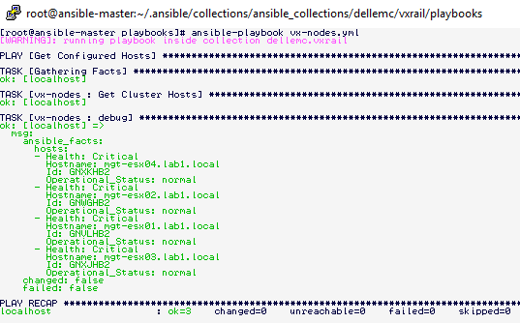

vCenter Mode (vx-vcmode)
Description: vx-vxmode performs the conversion of a VxRail deployed vCenter instance, to a hosted customer managed vCenter server. This is also referred to as vCenter externalization in which the vCenter VM remains on the VxRail cluster, but it is no longer managed by VxRail for tasks such as LCM and shutdown.
Dependencies:
- VxRail Manager must be accessible on the network
- The VxRail Cluster must be in a healthy state
- The Ansible control node must be configured to support ssh commands to the VxRail Manager.

Parameters:
vcadmin: vcenter administrative account
vcpasswd: vcenter administrator password
ip: vxrail manager resolvable FQDN or IP address

The module will perform the VxRail modification to externalize the vCenter server followed by a reboot of VxRail Manager.

If the system is already converted, or the cluster is not in a healthy state, a message will be returned indicating that the conversion cannot be completed.
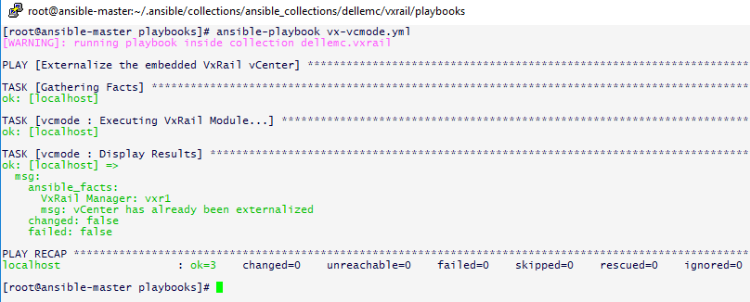

Disk Information (vx-diskinfo)
Description: vx-diskinfo provides a method to enumerate the cluster hosts and return details of all disks in the environment. This module can be used as an inventory or troubleshooting tool to assist in identifying details and location of disks in the cluster.
Dependencies:
- VxRail Manager must be accessible on the network
- The Ansible control node must be configured to support ssh commands to the VxRail Manager.

Parameters:
vcadmin: vcenter administrative account
vcpasswd: vcenter administrator password
ip: vxrail manager resolvable FQDN or IP address
failed: optional argument to return disk in unhealthy state
Note: There are numerous properties which are returned by the API, in its current form, the vx-diskinfo provides a subset of the details associated with each disk which are tailored towards disk capacity, identification, and health
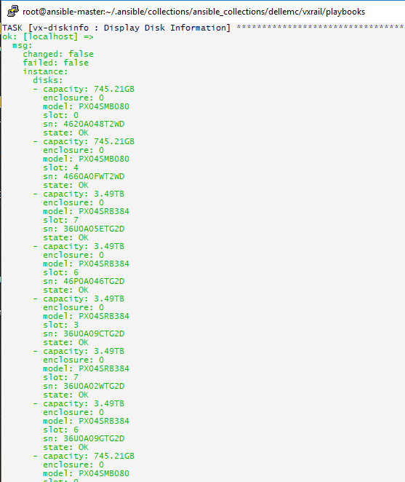
Specifying the option for failed will return only disks with a status other than ok.
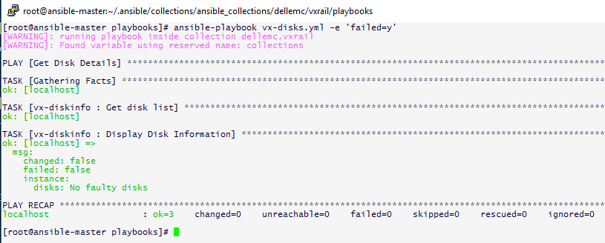

Cluster Modules

Initialization
Description: In VxRail 7.0, the VxRail Cluster can be initialized through an API call to the VxRail Manager.
This module will communicate with the VxRail Manager initialization API and include the configuration json file as the payload for the initialization method.
Dependencies
- VxRail Cluster nodes have been (re)set to factory image.
- Network configuration is completed to support cluster vDS port group configuration (management, vsan, vmotion).
- JSON file is available on ansible-control VM.
  - Json file must contain the VxRail serial number of the nodes within this cluster.
  - If that information is not available, it can be obtained from the UI init wizard.
​ /v1​/system​/initialize​/status

Upgrade

The cluster upgrade process makes use of multiple modules. The first module which is used, will copy the image file to the target VxRail Manager and also prepare the environment to bypass firmware pre-checks.

Copy Configuration Files (vx-copyconfig)
Description: The Upgrade module relies upon a playbook and role called vx-copyconfig.yml. That roles performs two separate tasks to prepare the VxRail Cluster for upgrade.
- It updatesd a modified version of the lcm_advanced_mode.properties file with a parameter that specifies bypass firmware pre-check tasks.
- It copies the Upgrade Bundle file from the ansible-control VM to the VxRail Cluster /tmp directory

Dependencies:
The vx-lcm module has the following requirements:
- Ansible control node must be configured for ssh access to the VxRail Manager server.
- The Bundle file for the upgrade must be uploaded to the Ansible control VM.
  - The location of the Bundle file is ~roles/files.
  - To address potential capacity and manageability issues, the files can be staged in a separate file system or NFS mount and linked using a sym link within the role.
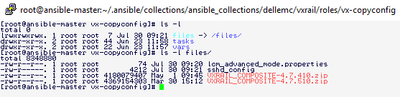

Parameters:
- vcadmin: vcenter administrative account
- vcpasswd: vcenter administrator password
- ip: vxrail manager resolvable FQDN or IP address

The vx-copyconfig playbook is listed below and illustrated the files to be copied and the Ansible format required to copy the files to the VxRail Manger host.

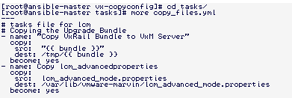

VxRail LCM (vx-lcm)
Description: The module performs the VxRail lifecycle management upgrade. The LCM process is an orchestration of multiple modules which perform the following tasks:

Dependencies:
The vx-lcm module has the following requirements:
- Ansible control node must be configured for ssh access to the VxRail Manager server.
- vx-copyconfig playbook has been completed
  - to modify VxRail lcm_advancedproperties and upload VxRail Composite Bundle file.
- Node firmware is being maintained by VxRail and consistent for the current release.
  - LCM is a complex workflow which expects the node firmware to meet the requirements for the existing release. Firmware that does not meet that requirement will cause the upgrade to fail.

Parameters:
- vcadmin: vcenter administrative account
- vcpasswd: vcenter administrator password
- ip: vxrail manager resolvable FQDN or IP address
- bundle: VxRail Image file uploaded to the files directory within the vx-lcm role.
      - Note this directory can be a symbolic link to a mount point or other directory on the control node.
- vcroot: The root account on the vCenter Appliance.
- vcrootpasswd: The password for the vCenter root account.
- psccroot: The root account for the PSC Appliance.
- pscrootpasswd: The password for the PSC root account.

Workflow Execution:
The vx-lcm module performs the following tasks
- Checks the health status of the cluster
- Uploads the Image file VxRail Manager
- Monitors the execution of this task and generates the output to /tmp/vx-lcm.log
- Initiates the LCM process
- Monitors the execution of LCM task and outputs the results to the /tmp/vx-lcm.log file.

In the event that the upgrade does fail, the errors associated with the failure can be viewed in the /tmp/vx-lcm.log file.
The log file contains the task ID for the upgrade process.
The VxRail Ansible playbook vx-requests.yml will return an ordered list of all tasks which have been executed on the VxRail Cluster. The LCM task ID can be obtained from the list and provided as input to the vx-req-id.yml to get details for the LCM task execution.
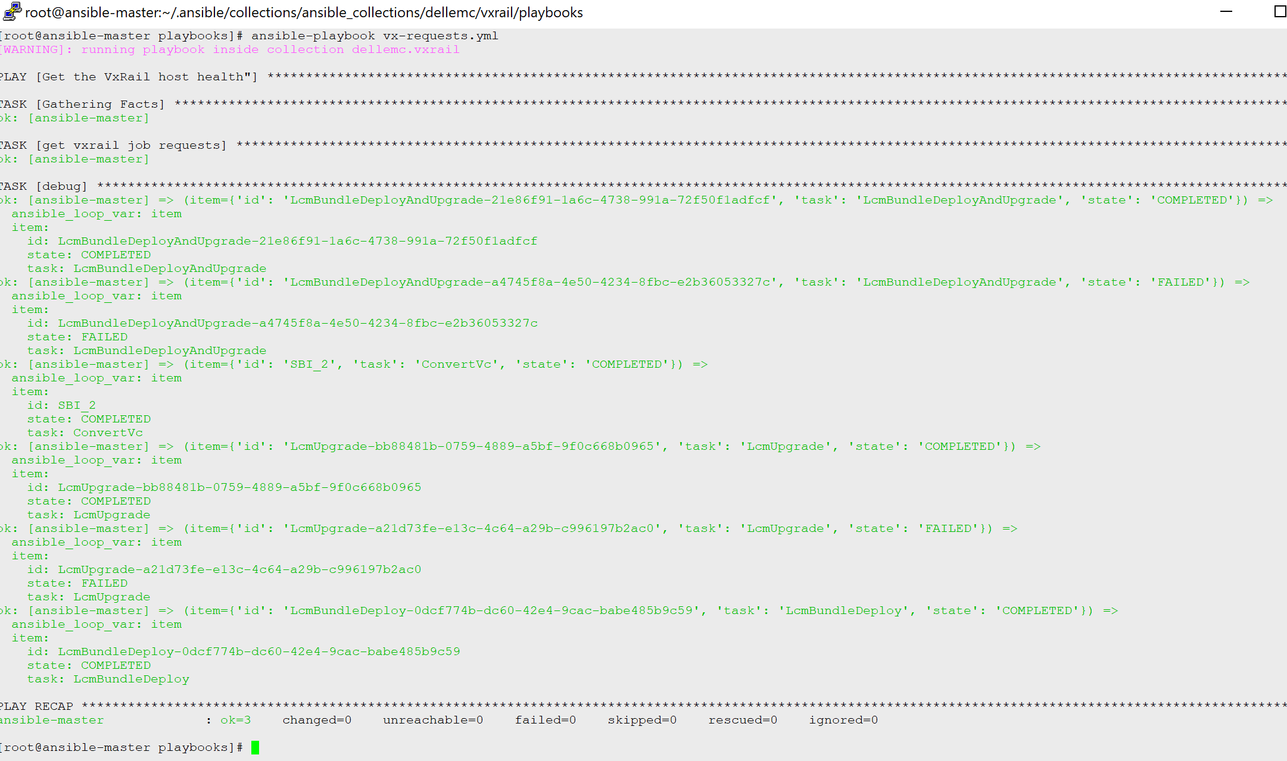

For detailed information on a specific task issue the use the vxrail playbook for request by id (vx-req-id.yml).
ansible-playbook vx-req-id.yml -e ‘id=<task id>”
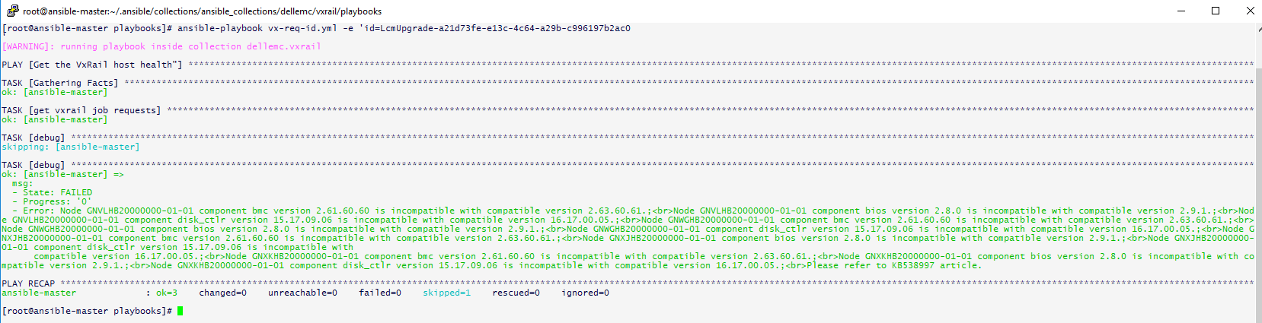

Cluster Health System Status (vx-health)

The vx-health module provides a method to validate system connectivity and return the current status of the system. In cases where there is a need to perform such validation, calling the vx_health.py module will provide that confirmation prior performing subsequent plays.
The vx-health confirms http connectivity and uses the /rest/vxm/v1/cluster/system-health API to return the current system status.
Dependencies:
- VxRail Manager must be accessible on the network
- The Ansible control node must be configured to support ssh commands to the VxRail Manager.

Required parameters:
- vcadmin: vcenter administrative account
- vcpasswd: vcenter administrator password
- ip: VxRail manager resolvable FQDN or IP address
Execution:
ansible-playbook vx-health.yml (optional -e ‘vxm=hostname’)
As with other playbooks, it is permissible to use the -e option to specify a different cluster that has been defined within the ansible.cfg hosts file.

Log File: /tmp/vx-health.log

Cluster Shutdown

- /rest/vxm/v1/cluster/shutdown
- Shuts down a cluster or performs a shutdown dry run
- Supported Versions >= 4.5.3xx

Ansible:
---
- name: Shutdown VxRail Cluster Playbook
hosts: localhost
tasks:
- name: Shutdown VxRail Cluster
uri:
url: https://172.18.78.37/rest/vxm/v1/cluster/shutdown
user: "administrator@vsphere.local"
password: "Vxr@il123!"
method: POST
force_basic_auth: yes
status_code: 202
validate_certs: false
body_format: json
body:
dryrun: false
register: data
- name: Print returned json dictionary
debug:
var: data.json

Response
PLAY [Shutdown VxRail Cluster Playbook] ***********************************************************************

TASK [Gathering Facts] ****************************************************************************************
ok: [localhost]

TASK [Shutdown VxRail Cluster] ********************************************************************************
ok: [localhost]

TASK [Print returned json dictionary] *************************************************************************
ok: [localhost] => {
"data.json": {
"request_id": "a290515d-b219-4f50-a234-4818541d70da"
}
}

PLAY RECAP ****************************************************************************************************
localhost : ok=3 changed=0 unreachable=0 failed=0 skipped=0 rescued=0 ignored=0

Log Collection (vx-logs)

If for any reason the upgrade fails, the Request by ID call will return a state of “Failed” along with an error message specifying the cause. Below are two examples of responses after a failed upgrade:

The vx-getlogs playbook calls the (vx_getlog.py) module to generate and retrieve the VxRail support logs for the specific cluster. The default behavior is to generate the vxm logs for all nodes within the cluster.
Dependencies:
- VxRail Manager must be accessible on the network
- The Ansible control node must be configured to support ssh commands to the VxRail Manager.

Required parameters:
- vcadmin: vcenter administrative account
- vcpasswd: vcenter administrator password
- ip: vxrail manager resolvable FQDN or IP address

Execution:
ansible-playbook vx-getlogs.yml
As with other playbooks, it is permissible to use the -e option to specifiy a different cluster that has been defined within the ansible.cfg hosts file.The module will perform the request of the system log files and return the path to the log file bundle on the VxRail Manager.
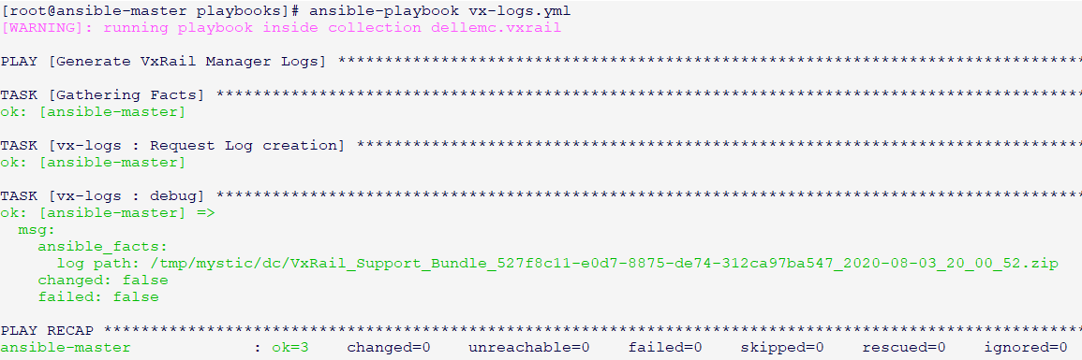
This call will create a log bundle on the VxRail Manager in the following directory: ‘/tmp/mystic/dc’.
Log files related to LCM include:
    - /var/log/mystic/web.log
    - /var/log/mystic/lcm.log
    - /var/log/mystic/vxrail-clm-cli.log
    - /var/log/mystic/lcm_cli_console

The file-copy playbook can be used to automate the retrieval of the files i
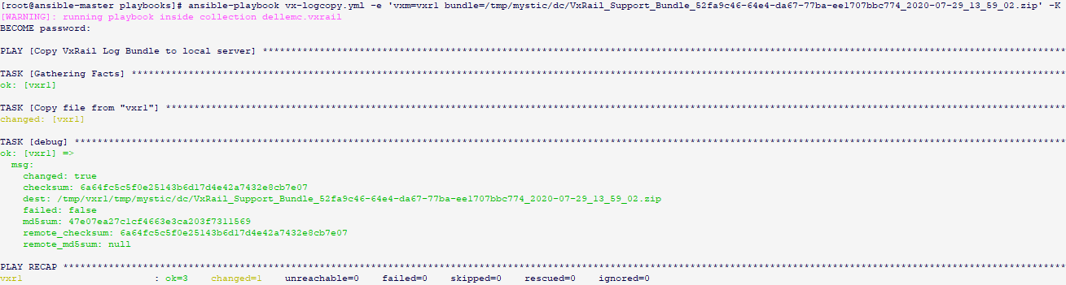

System returns an error indicating that VxRail Manager is unavailable or similar authentication error as seen below.

The first point to note is that validation of the API can be performed using the swagger interface on the VxRail Manager. In cases where there appears to be an access or authentication issue, the swagger interface is a good tool isolate the issue to the playbook or the VxRail Manager instance.

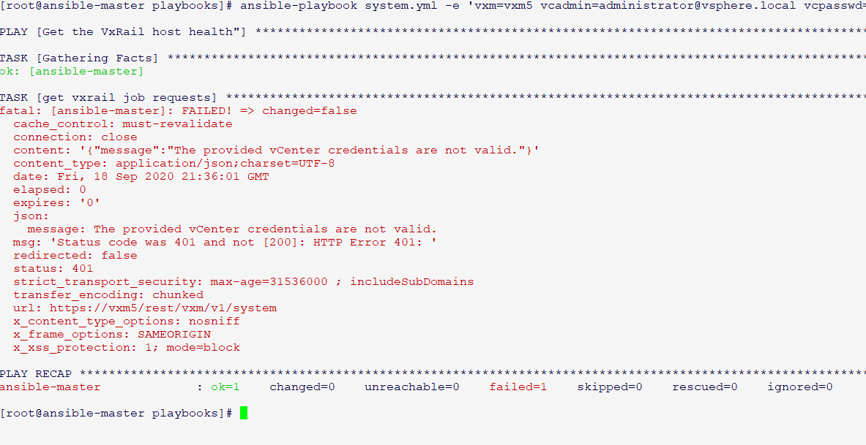

Appendix B: VxRail 7.0 JSON Configuration file.
{
"version": "7.0.010",
"global": {
"cluster_type": "STANDARD",
"ntp_servers": [
"170.0.0.254"
],
"is_internal_dns": true,
"dns_servers": [],
"syslog_servers": [],
"top_level_domain": "lab5.local",
"cluster_management_netmask": "255.255.255.0",
"cluster_management_gateway": "172.17.32.1",
"cluster_vsan_netmask": "255.255.255.0",
"cluster_vmotion_netmask": "255.255.255.0"
},
"hosts": [
{
"host_serial_number": "8QWXLR2",
"hostname": "mgt-esx01",
"accounts": {
"root": {
"username": "root",
"password": "VMw@re123!"
},
"management": {
"username": "vxadmin",
"password": "VMw@re123!"
}
},
"geo_location": {
"rack_name": null,
"position": null
},
"network": [
{
"type": "MANAGEMENT",
"ip": "172.17.32.11"
},
{
"type": "VSAN",
"ip": "172.17.33.11"
},
{
"type": "VMOTION",
"ip": "172.17.34.11"
}
]
},
{
"host_serial_number": "8QWZHQ2",
"hostname": "mgt-esx02",
"accounts": {
"root": {
"username": "root",
"password": "VMw@re123!"
},
"management": {
"username": "vxadmin",
"password": "VMw@re123!"
}
},
"geo_location": {
"rack_name": null,
"position": null
},
"network": [
{
"type": "MANAGEMENT",
"ip": "172.17.32.12"
},
{
"type": "VSAN",
"ip": "172.17.33.12"
},
{
"type": "VMOTION",
"ip": "172.17.34.12"
}
]
},
{
"host_serial_number": "8QXVLR2",
"hostname": "mgt-esx03",
"accounts": {
"root": {
"username": "root",
"password": "VMw@re123!"
},
"management": {
"username": "vxadmin",
"password": "VMw@re123!"
}
},
"geo_location": {
"rack_name": null,
"position": null
},
"network": [
{
"type": "MANAGEMENT",

"ip": "172.17.32.13"
},
{
"type": "VSAN",
"ip": "172.17.33.13"
},
{
"type": "VMOTION",
"ip": "172.17.34.13"
}
]
},
{
"host_serial_number": "8QXWLR2",
"hostname": "mgt-esx04",
"accounts": {
"root": {
"username": "root",
"password": "VMw@re123!"
},
"management": {
"username": "vxadmin",
"password": "VMw@re123!"
}
},
"geo_location": {
"rack_name": null,
"position": null
},
"network": [
{
"type": "MANAGEMENT",
"ip": "172.17.32.14"
},
{
"type": "VSAN",
"ip": "172.17.33.14"
},
{
"type": "VMOTION",
"ip": "172.17.34.14"
}
]
}
],
"vcenter": {
"customer_supplied": false,
"vxrail_supplied_vc_ip": "172.17.32.9",
"vxrail_supplied_vc_name": "mgt-vcenter",
"accounts": {
"root": {
"username": "root",
"password": "VMw@re123!"
},
"administrator": {
"username": "administrator@vsphere.local",
"password": "VMw@re123!"
},
"management": {
"username": "vxadmin",
"password": "VMw@re123!"
}
}
},
"network": {
"vds": {
"nic_profile": "TWO_HIGH_SPEED",
"systemvm_portgroup_binding_type": "EPHEMERAL",
"portgroups": [
{
"type": "MANAGEMENT",
"vlan_id": 0
},
{
"type": "VSAN",
"vlan_id": 1733
},
{
"type": "VMOTION",
"vlan_id": 1734
}
]
}
},
"vxrail_manager": {
"name": "mgt-vxm",
"ip": "172.17.32.10",
"accounts": {
"root": {
"username": "root",
"password": "VMw@re123!"
},
"service": {
"username": "mystic",
"password": "Emc-1234!"
}
}
}
}

